EXPERIMENT 10
AIM: To design BI deployment, monitoring, backup and recovery strategies using Microsoft Power BI to ensure system reliability and business continuity.
OBJECTIVES:
- Identify BI deployment requirements.
- Design workspace structures and roles.
- Prepare monitoring strategies for BI solutions.
- Develop backup and recovery procedures.
- Analyze disaster recovery scenarios.
THEORY:
Business Intelligence solutions require proper deployment, monitoring and maintenance to ensure continuous availability. Deployment makes reports and dashboards accessible to authorized users. Monitoring tracks dataset refreshes, report performance and user activity. Backup and restore mechanisms protect BI assets from accidental deletion, corruption and system failures. These processes help maintain reliability and business continuity.
TOOLS / SOFTWARE REQUIRED:
- Microsoft Power BI Desktop
- Microsoft Power BI Service
- Global Superstore Dataset.xlsx
- Microsoft Excel
- Microsoft PowerPoint (Optional)
DATASET USED:
Global Superstore Dataset containing sales, profit, customer, product and regional information.
PROCEDURE:
- Open the existing Global Superstore Power BI report and identify BI assets created in previous experiments.

- List reports, dashboards, datasets and workspaces that require deployment.

- Prepare a BI Deployment Plan specifying deployment objectives, intended users and departments.
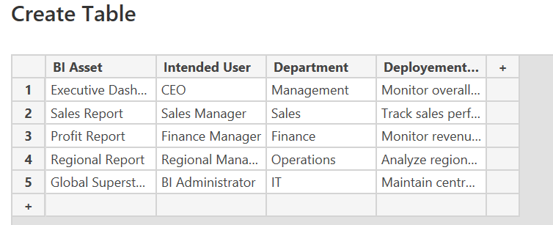
- Design a Power BI Workspace structure and identify roles such as Administrator, Member, Contributor and Viewer.
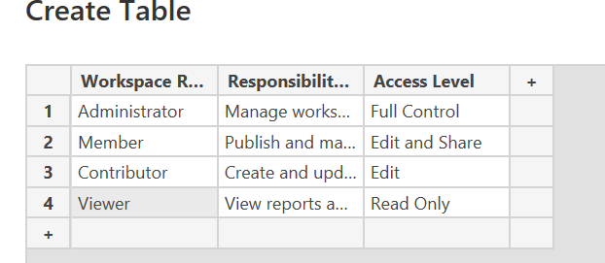
- Assign responsibilities to each workspace role and define governance guidelines.

- Identify monitoring requirements such as dataset refresh status, dashboard usage, report performance and user activity.

- Prepare a Monitoring Matrix specifying monitoring metrics, frequency and responsible personnel.
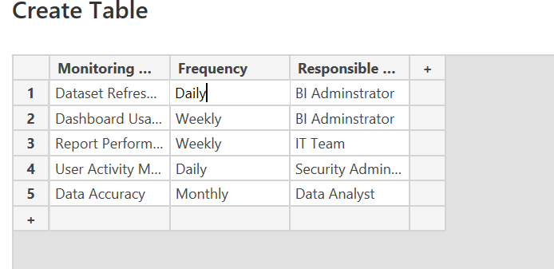
- Identify BI components requiring backup and prepare a daily, weekly and monthly Backup Schedule.
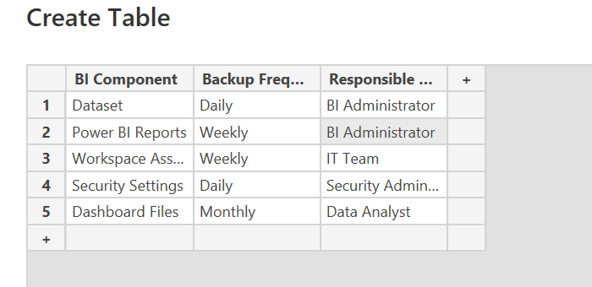
- Design a Restore Procedure for accidental deletion or system failure.
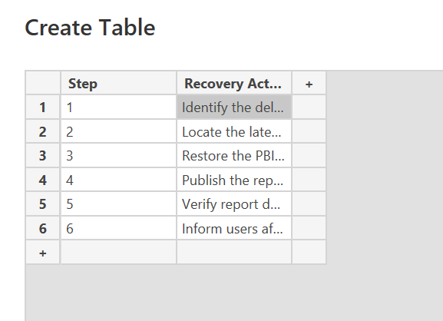
- Analyze the executive dashboard deletion scenario and prepare a Disaster Recovery Report with business continuity recommendations.

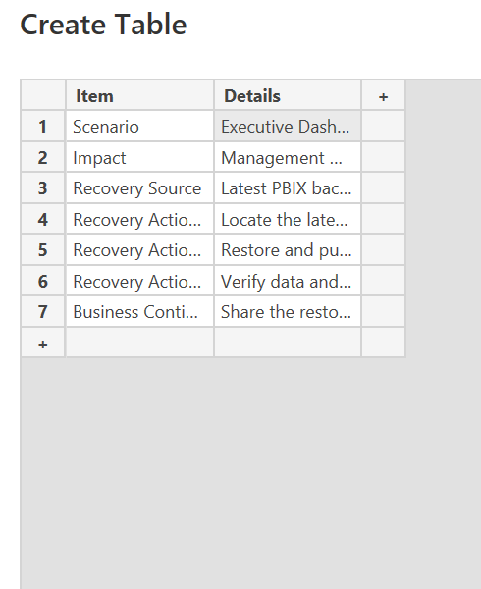

RESULT:
A BI deployment, monitoring, backup and recovery strategy was designed. Workspace roles, monitoring requirements, backup schedules and disaster recovery procedures were documented.
LEARNING OUTCOMES:
- Analyzed BI deployment requirements.
- Designed workspace structures and governance models.
- Evaluated BI monitoring requirements.
- Developed backup and recovery strategies.
- Prepared business continuity plans.

